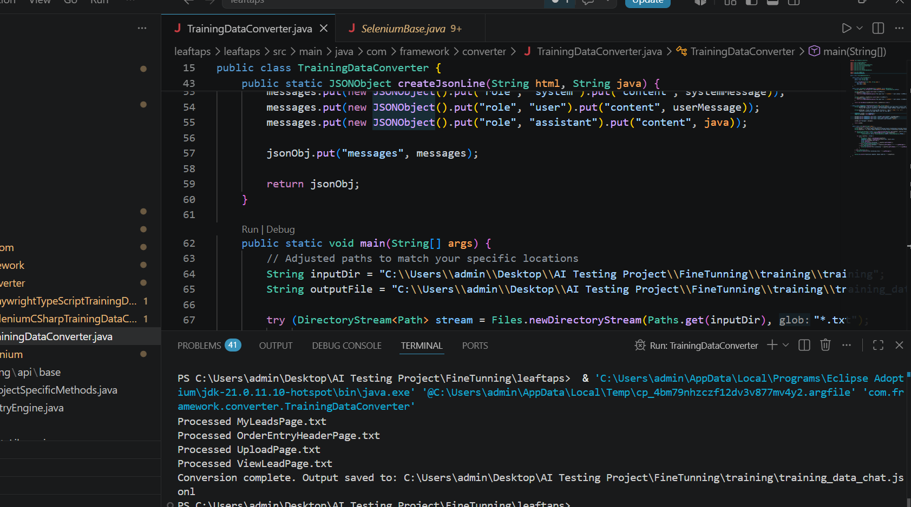
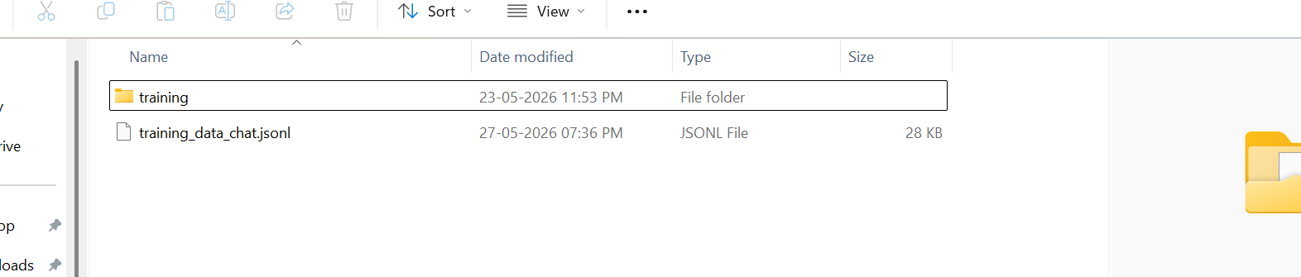
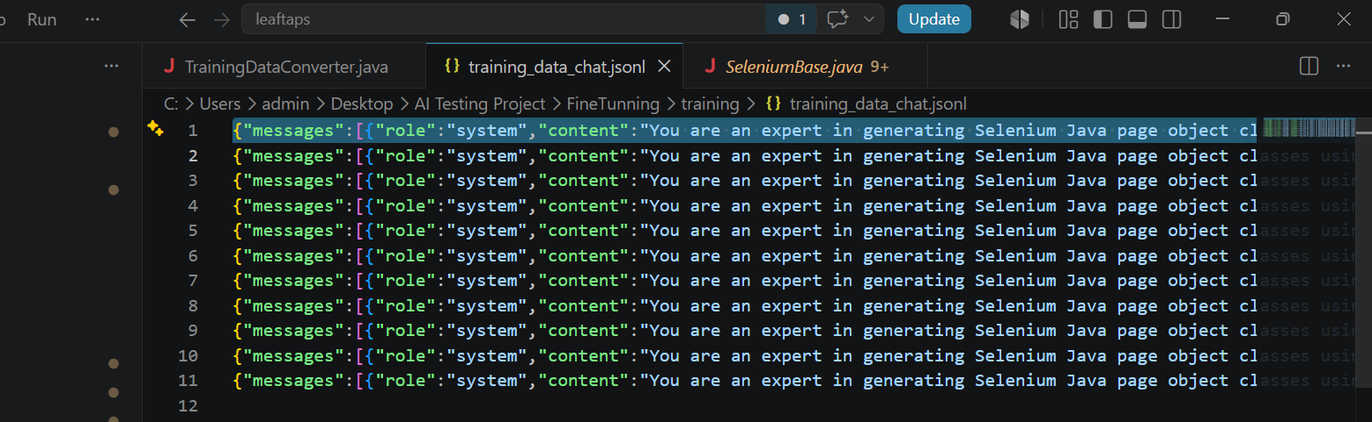
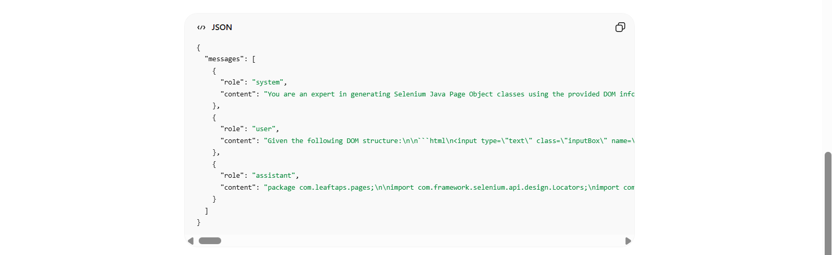
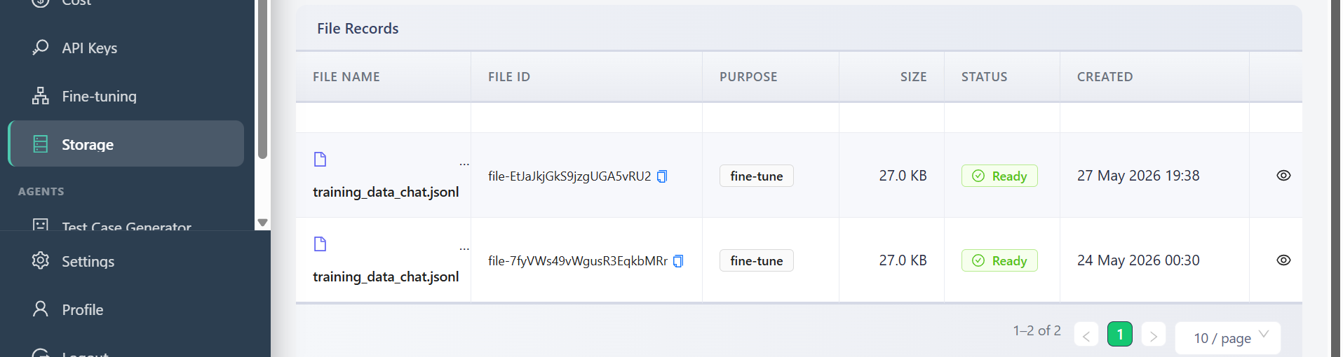
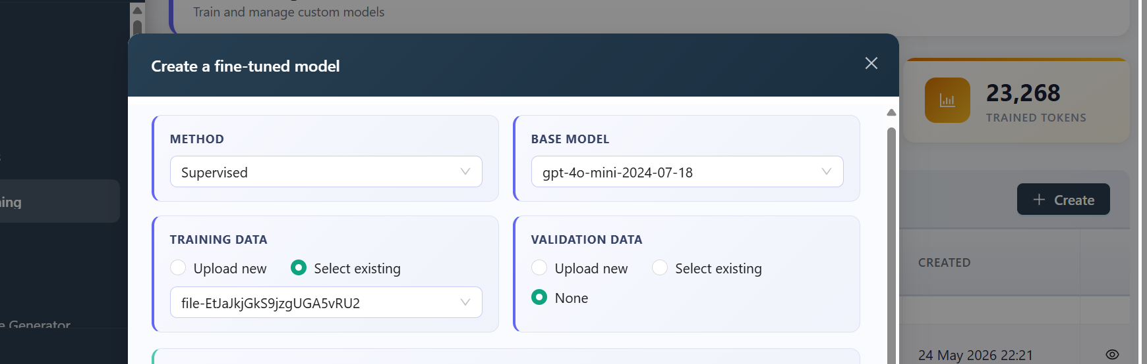
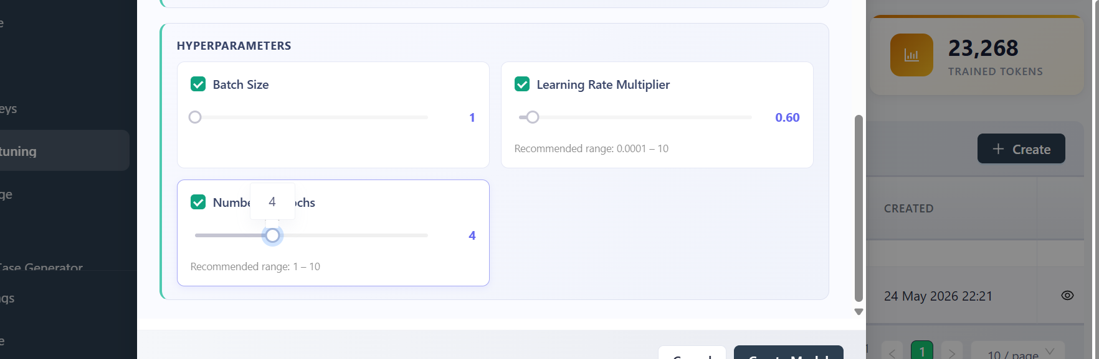
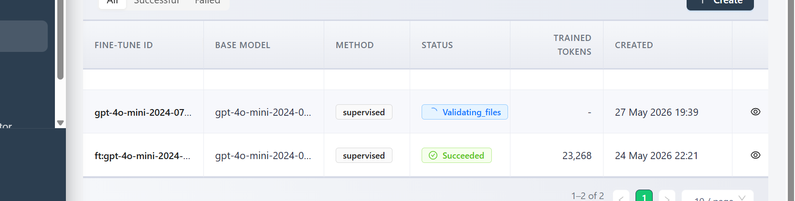
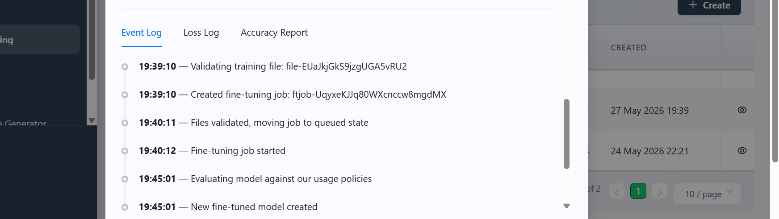
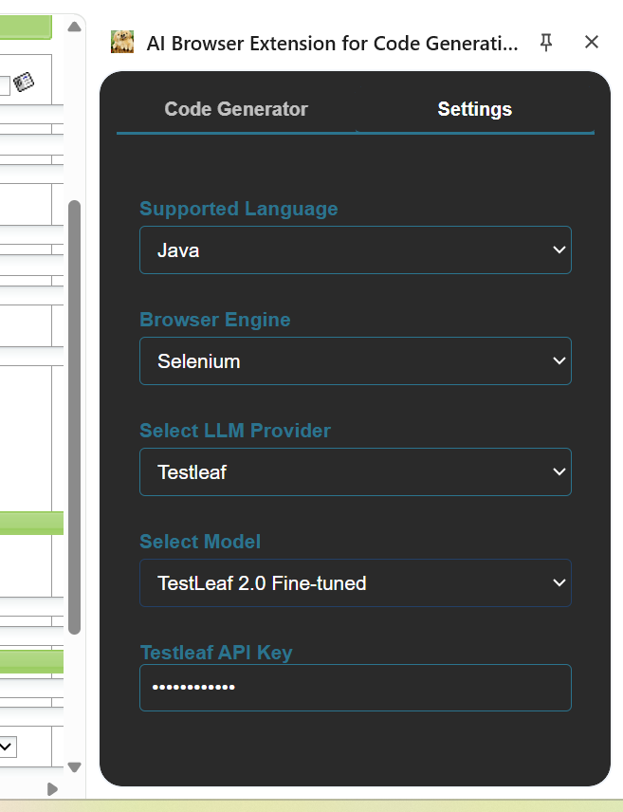
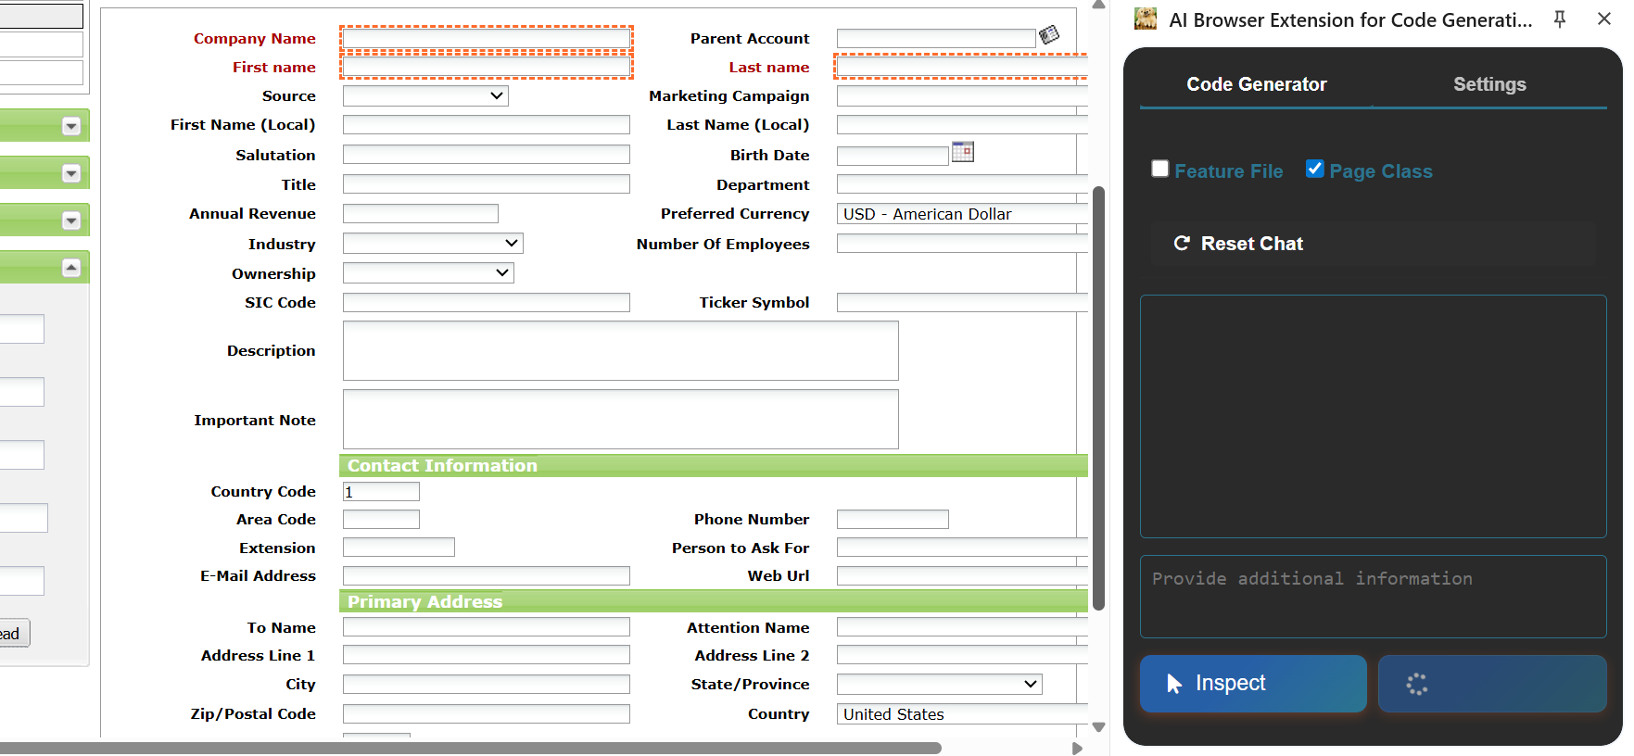

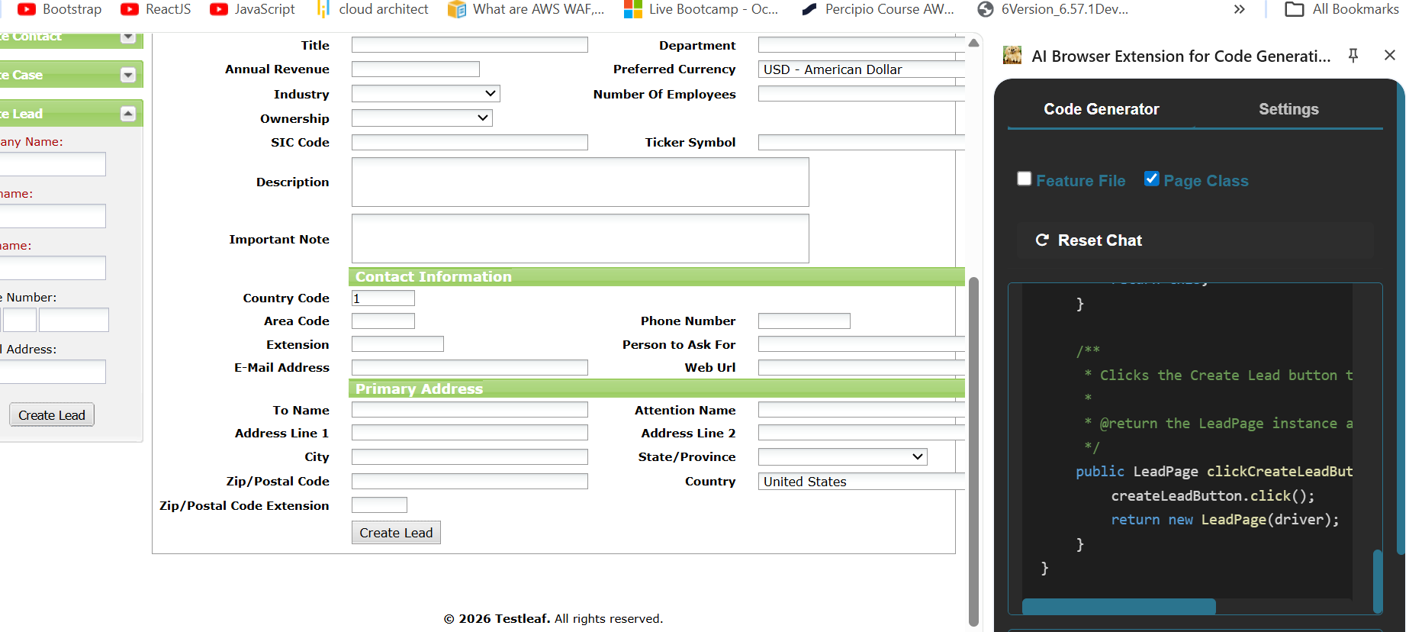
package com.testleaf.pages;

import org.openqa.selenium.WebElement;
import org.openqa.selenium.support.FindBy;
import org.openqa.selenium.support.PageFactory;
import org.openqa.selenium.remote.RemoteWebDriver;

/**
* Page Object for Create Lead Page
*/
public class CreateLeadPage {

private RemoteWebDriver driver;

/**
* Initializes the CreateLeadPage with the given driver.
*
* @param driver the WebDriver instance
*/
public CreateLeadPage(RemoteWebDriver driver) {
this.driver = driver;
PageFactory.initElements(driver, this);
}

@FindBy(id = "createLeadForm_companyName")
private WebElement companyNameField;

@FindBy(id = "createLeadForm_lastName")
private WebElement lastNameField;

@FindBy(name = "submitButton")
private WebElement createLeadButton;

/**
* Enters the company name in the company name field.
*
* @param companyName the company name to enter
* @return the current CreateLeadPage instance
*/
public CreateLeadPage enterCompanyName(String companyName) {
companyNameField.clear();
companyNameField.sendKeys(companyName);
return this;
}

/**
* Enters the last name in the last name field.
*
* @param lastName the last name to enter
* @return the current CreateLeadPage instance
*/
public CreateLeadPage enterLastName(String lastName) {
lastNameField.clear();
lastNameField.sendKeys(lastName);
return this;
}

/**
* Clicks the Create Lead button to submit the form.
*
* @return the LeadPage instance after form submission
*/
public LeadPage clickCreateLeadButton() {
createLeadButton.click();
return new LeadPage(driver);
}
}

